Team Red – Task 5

# Task specification:

## Task description

1. Based on the review categories given in script 03.07 on slide 2, conduct a requirements review of the requirements document from Task 4 **-> Team Red evaluates work of team Green**
2. Document your results in a short review report table (approx. 1 page), including recommendations how the requirements document could be improved.

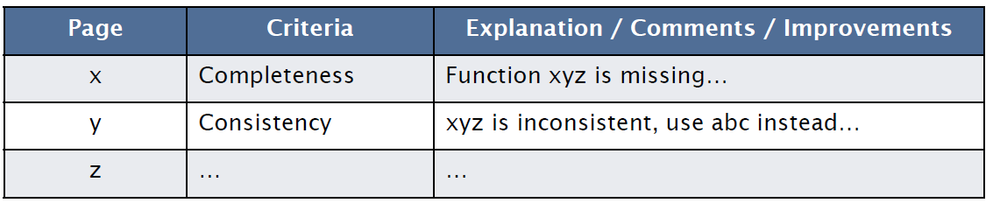

1. Award an overall grade to the report: 0-10 points
2. Send report to reviewed team

## Script 03.07: Evaluation of a requirements document

* **Comprehensibility:** Is the requirement properly understood
* **Validity:** Will the system provide the functions which best support the customer’s needs
* **Consistency:** Are there any requirement conflicts
* **Completeness:** Are all functions required by the customer included
* **Realism:** Can the requirements be implemented given available budget and technology
* **Verifiability:** Can the requirements be checked
* **Traceability:** Is the origin of the requirement clearly stated
* **Adaptability:** Can the requirement be changed without a large impact on other requirements?

How can we validate requirements? **-> E.g. Weighted Point Evaluation system**

# Task solution

## Glossary

Define the term “client” too to avoid misunderstandings since patients are often also referred to as “clients”.

The client/users don’t know agile development practices (mentioned in System evolution) therefore this should also be defined as well as “sprints” (mentioned in Testing).

## Functional User requirements

|  |  |  |
| --- | --- | --- |
| Req # | Category | Comment |
| 10 | Realism | Health visitors don't have access to a Patient's File, such uploads must be validated by a doctor. |
| 12 | Validity | As doctors aren't primarily users of the program, they will not participate in the chat, consider using a mailing system (e.g. with additional options) instead. |
| 9 | Realism | Difficult to realize respecting data protection act. (any such publication must most likely be approved by the patient) |
| 17 | Completeness | Consider making a general 'contacts' page that can be extended to multiple purpose. |
| 18 | Consistency | This event should not be related to a visit, a section "accommodation" in patient's documentation might be more efficient. |
| ALL | Consistency | Mentioning 13 makes mentioning 16 unnecessary |
| ALL | Completeness | Not mentioned that the user wants to initially create appointments in their timetable. See 15, 21, 22 |

## Non Functional User requirements

|  |  |  |
| --- | --- | --- |
| Req # | Category | Comment |
| 2 | Verifiability / Realism | Provide a server/system up time in %  “Always” is not a reachable goal. Consider a plan B for the most important uses in case the system doesn’t work (e.g. printouts of some documents) |
| 3 | Traceability | Consider mentioning that parts like the alarm button must be perfectly reliable not the whole application (testing effort). |
| 4 | Verifiability | Specify “short loading times”, especially mention the case that the application has to be loaded over a slow 2G/3G connection when WiFi/4G is unavailable. |
| 6 | Verifiability | Not verifiable, consider "modular architecture" or "plugin supporting architecture" |
| ALL | Completeness | Should state on what device types the application runs |

## Functional System requirements

|  |  |  |
| --- | --- | --- |
| Req # | Category | Comment |
| 2 | Comprehensibility | It's not clear what data is mentioned here. If this refers to the backup case of 1, this should be clearly stated. |
| 8 | Verifiability | What kinds of exports / imports should be supported (e.g. print, scan, file types). |
| 4 | Verifiability | Mention what functions must be accessible by web (defines costs). |
| 7 | Completeness | Also mention the need for user groups with different access right (administrators, dept. leaders, health visitors). |

## Non Functional System requirements

|  |  |  |
| --- | --- | --- |
| Req # | Category | Comment |
| 1 | Verifiability | Specify what kind of attacks, measures |
| 2 | Verifiability / Realism | Provide a server/system up time in %  “Always” isn’t a reachable goal. |
| 4 | Realism | Not all Data is available offline due to storage and data protection (e.g. a device getting lost). Instead of "most recent data" it should be stated "recently used data" (i.e. caching). |
| 5 | Comprehensibility | Not stated if small or big error tolerance or which context. |
| 6 | Verifiability | Not verifiable, consider "modular architecture" or "plugin supporting architecture" |
| 7 | Verifiability | Consider mentioning the kind of interfaces to provide (web service, API). |

## General

Since end users as well as the client belong to the expected readership and you can’t expect them to have much technical know-how the document could be shorter to make it easier for them to understand it. This could be achieved by merging user requirements and leaving out information that is not yet needed or might still change at the current stage (e.g. the system model).

Stick to only on language per document. Switching between English titles and German text makes a document harder to read.